**Deployment Manual**

**Project Name: Library Management System**

**Team Members:**

**1. Indian Bittu**

**2. Adhithya KR**

**3. Silpa ER**

**4. Sudarshan Reddy H**

**5. Koppolu Harsha Vardhan Reddy**

**GitHub Detail:**

**GitHub Link:** <https://github.com/ib321/Library_Management_System.git>

**Passwords Used:**

**1. Oracle Database Credentials:**

* Username= SYSTEM
* Password= ib123

**2. Application Default Login Credentials:**

* Username= Admin
* Password= Admin
* Username= ib123
* Password= ib

**Port Numbers used in Application:**

* **Spring Boot Application Tomcat Server Port Number =** 8098
* **Angular Application Port Number =** 4200

**Angular Application Main Application Run Link:**

* **Link = http://localhost:4200**

**Steps To Add Project in local work Space from GitHub Using Git Bash:**

1. **Download git **
2. **Create Folder in workspace**
3. **Open git bash**
4. **Copy workspace Folder Path**

**5.Use cd command Then Paste the workspace path**

**$ cd C:/Library_Management_System**

**6. Copy Link of GitHub Code then in Git Bash use git clone and paste the link**

**$ git clone** <https://github.com/ib321/Library_Management_System.git>

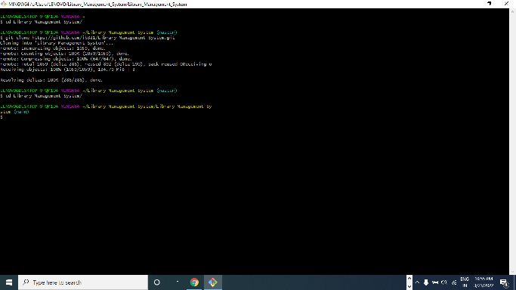

**7. Open Eclipse**

**8. Go to File Menu Choose “Open project from File System”**

**Open Folder Path of cloned GitHub Java Project**

**9. Press Next and Finish Importing Library_Management_System project on eclipse**

**10. Right click on project Name**

**Go to Run as 🡪 1. Maven clean ( then press F5 to refresh)**

**2. Maven build enter [ goals=clean install ]**

**11. Go to com.lib package then open Main Class** @SpringBootApplication

**12. Right click and Run As “Java Application”**

**Maven Clean:**

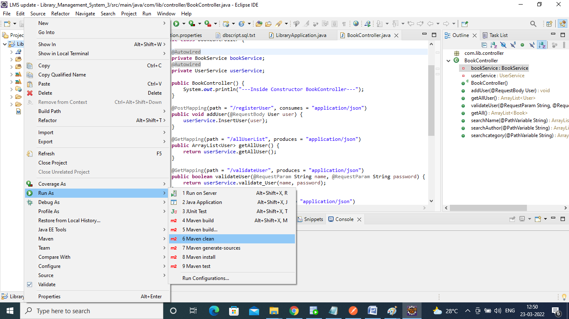

**Maven Clean Success:**

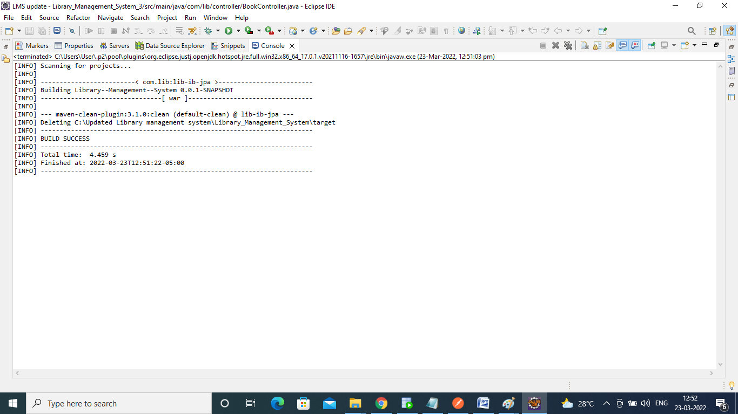

**Refresh:**

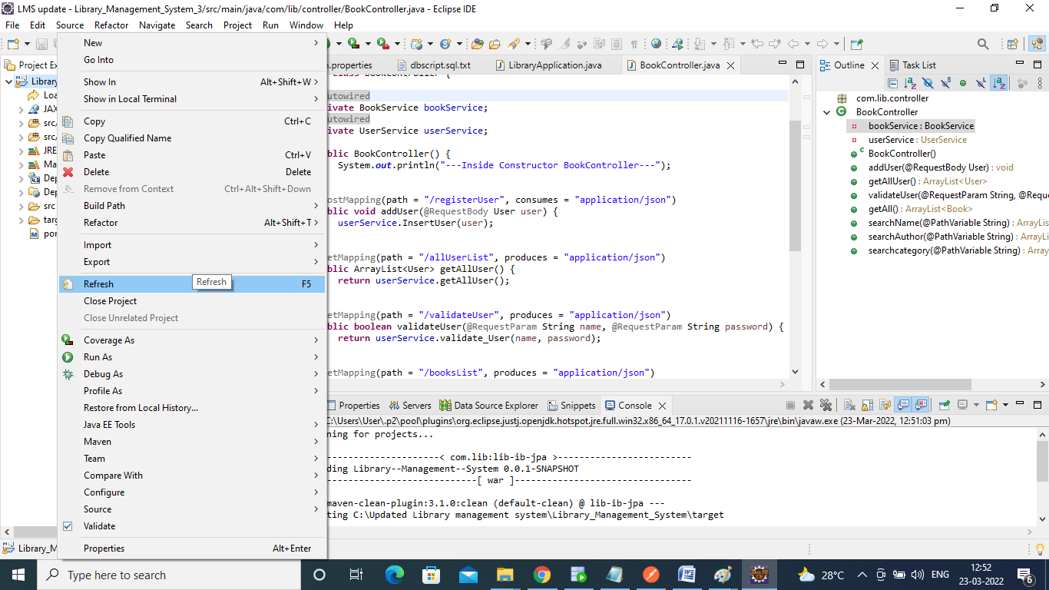

**Maven Build:**

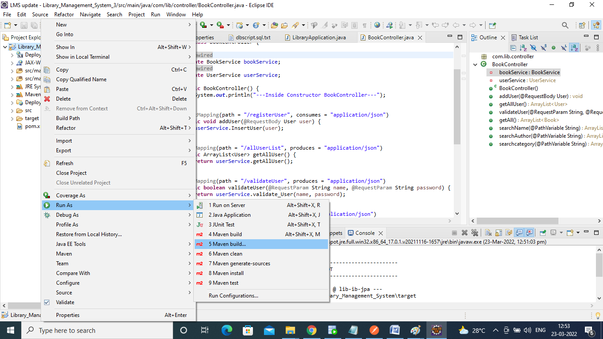

**Give Goals: “clean install” Apply then Run:**

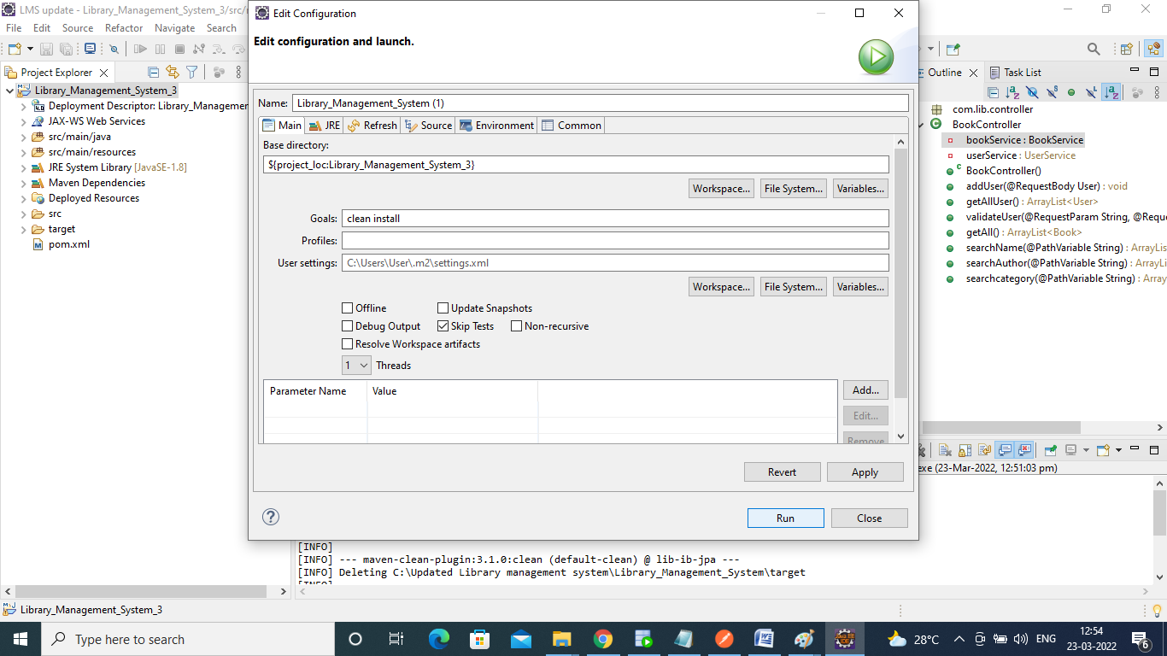

**Maven Build success:**

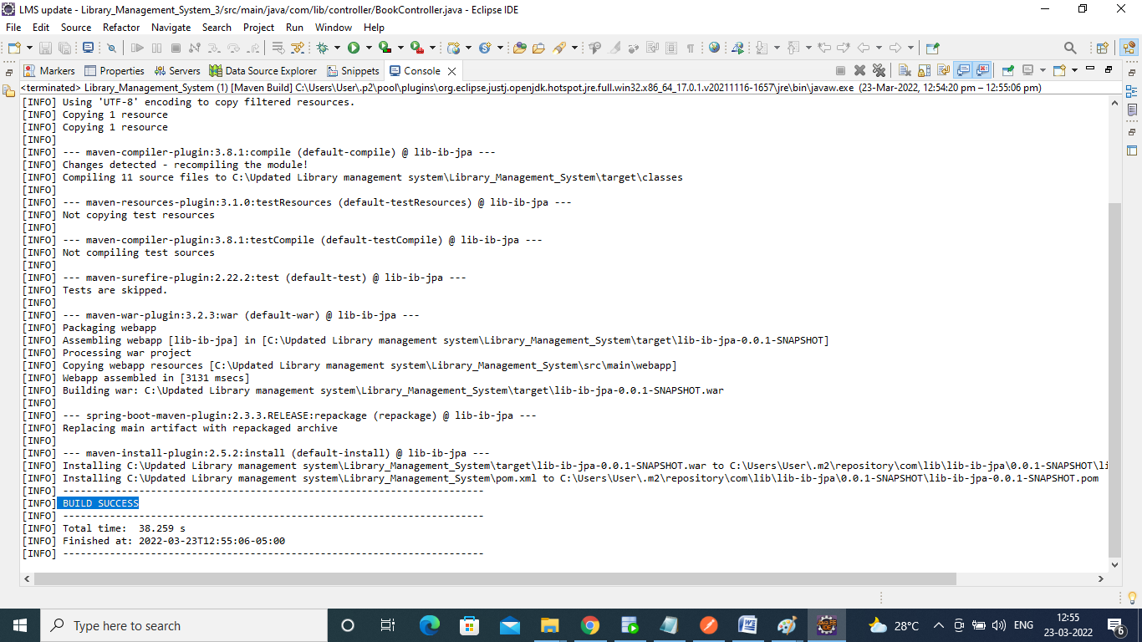

**Data Base:**

1. **We have to Download Oracle 11g and SQL developer**
2. **Then we can create tables Book, User**

**GitHub link for the Database script:**

* **GitHub Link for the Book Script:**

[**https://github.com/ib321/Library_Management_System/blob/main/DataBase%20Script/book.sql**](https://github.com/ib321/Library_Management_System/blob/main/DataBase%20Script/book.sql)

* **GitHub project link for User script:**

[**https://github.com/ib321/Library_Management_System/blob/main/DataBase%20Script/user.sql**](https://github.com/ib321/Library_Management_System/blob/main/DataBase%20Script/user.sql)

**Create tables:**

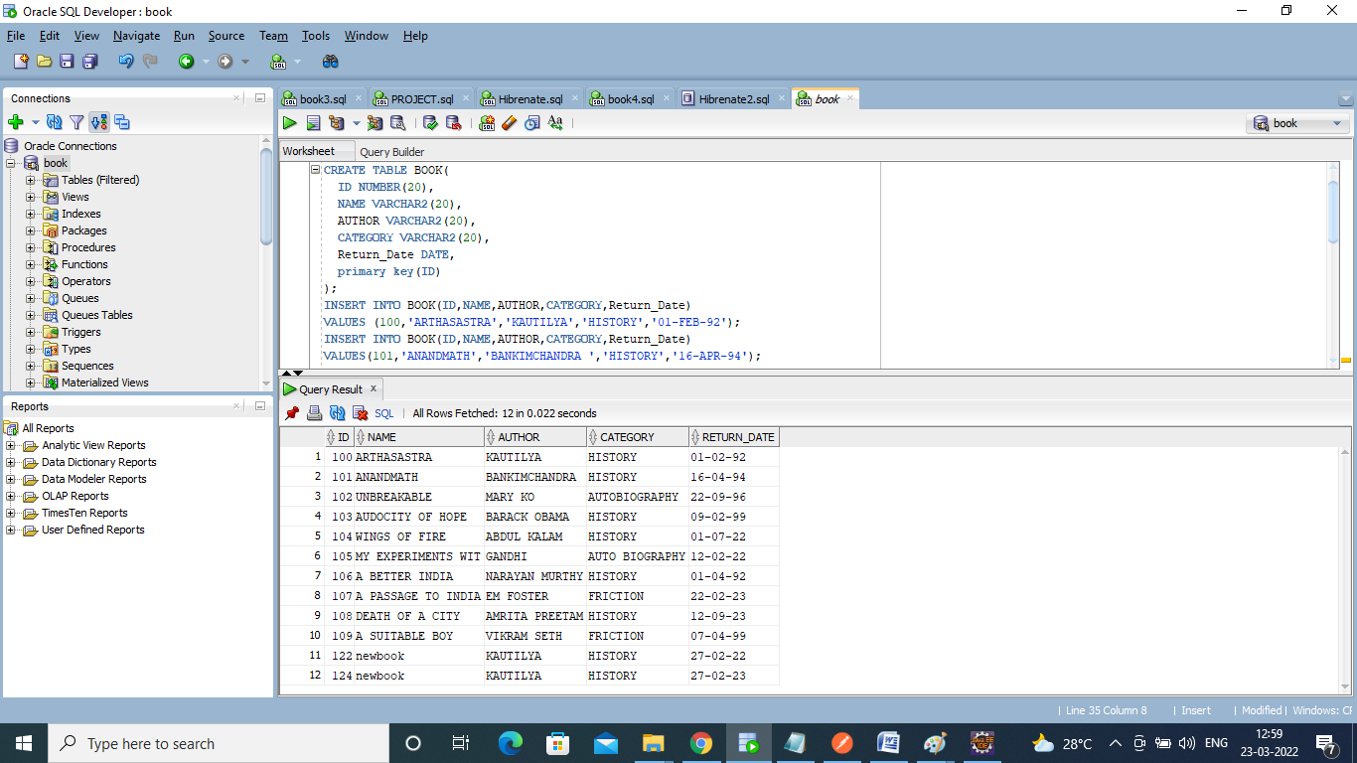

**Angular Js:**

1. **First, we download**
2. **Download and install Node.js (including NPM) in windows system**

<https://nodejs.org/en/download/>

1. **Go to Command Prompt**
2. **Command to check the Node.js version installed in system: node -v**
3. **Install the Angular CLI: npm install -g @angular/cli**
4. **Command to check Angular version installed in your system: ng –version**
5. **Go to GitHub Cloned Folder to webapp/view/**
6. **Change directory to your application using: cd libraryApplication**
7. **Compile and Run the Angular App: ng serve**
8. **Open browser and access the Application using the below URL:** <http://localhost:4200/>

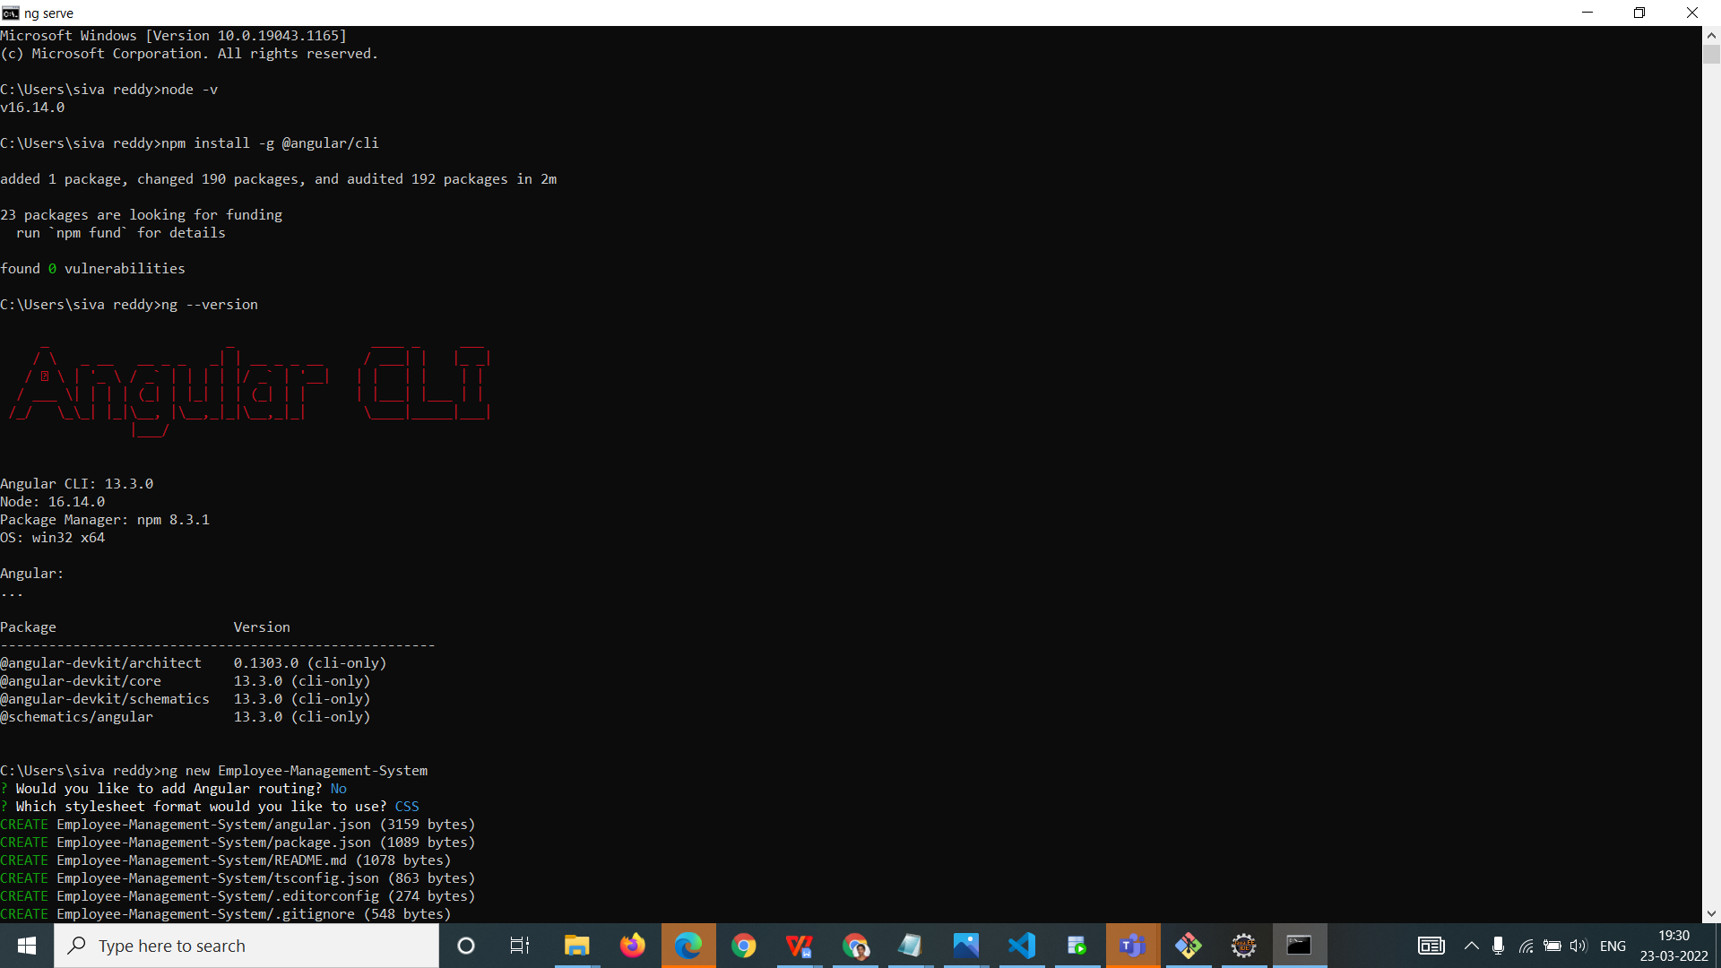

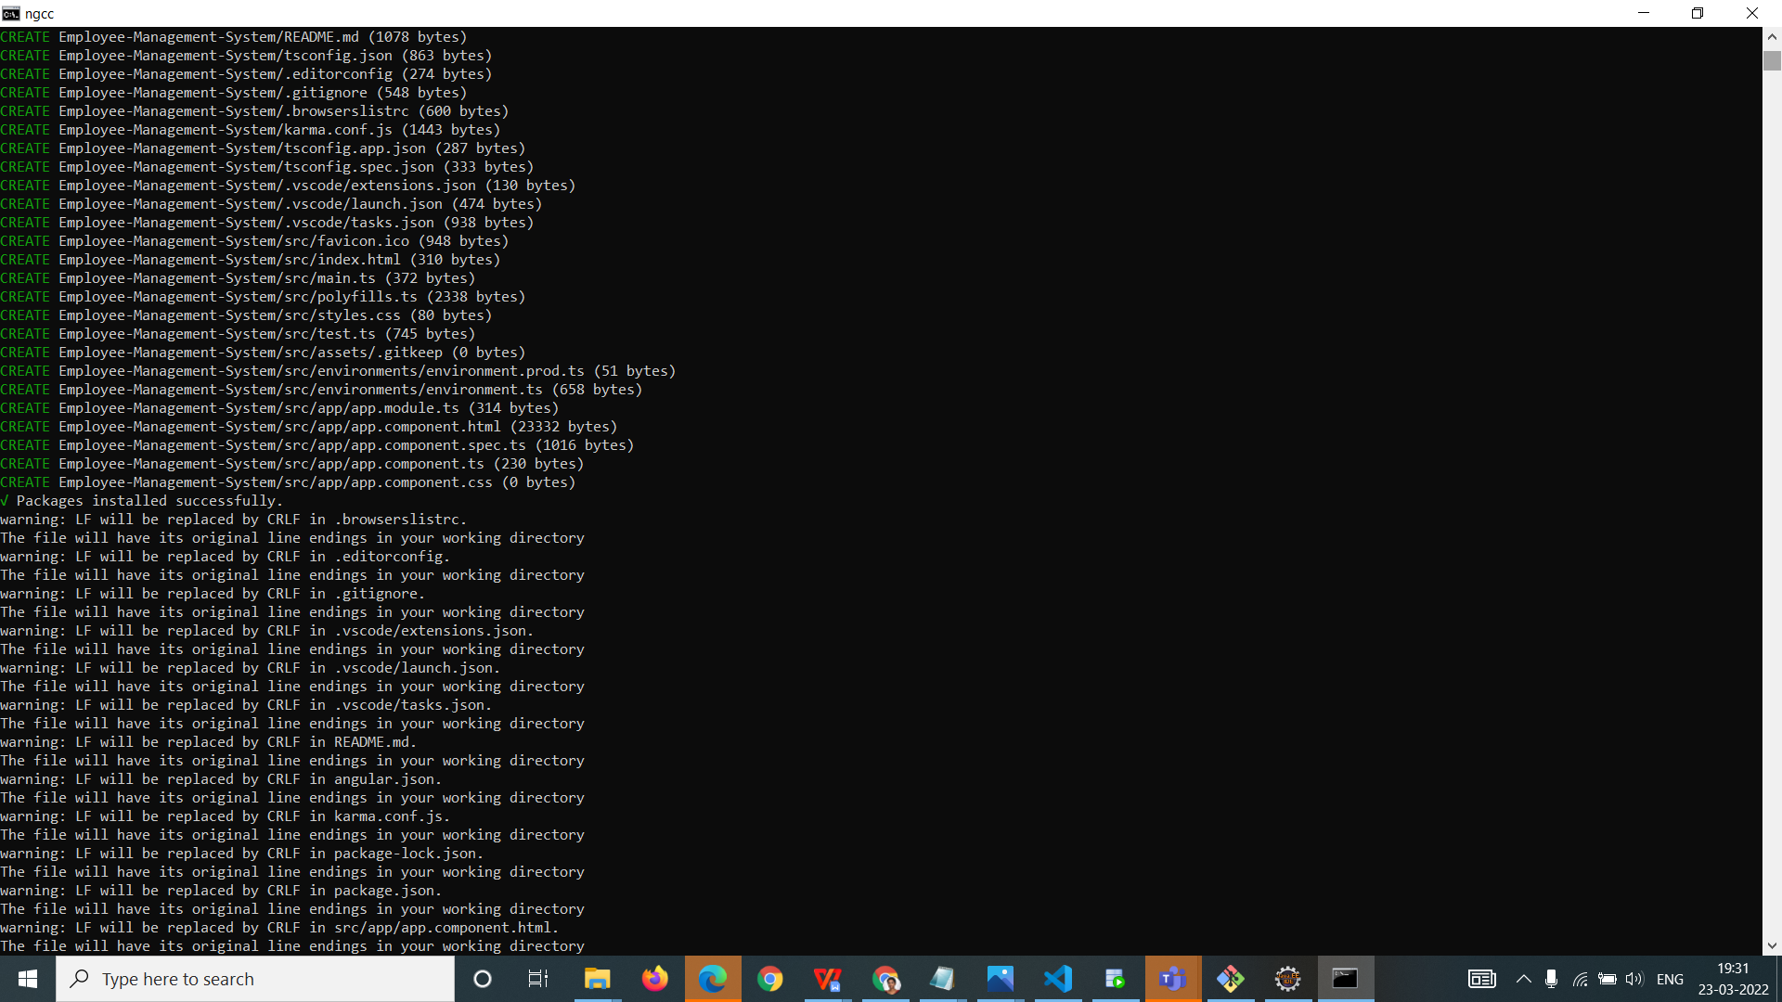

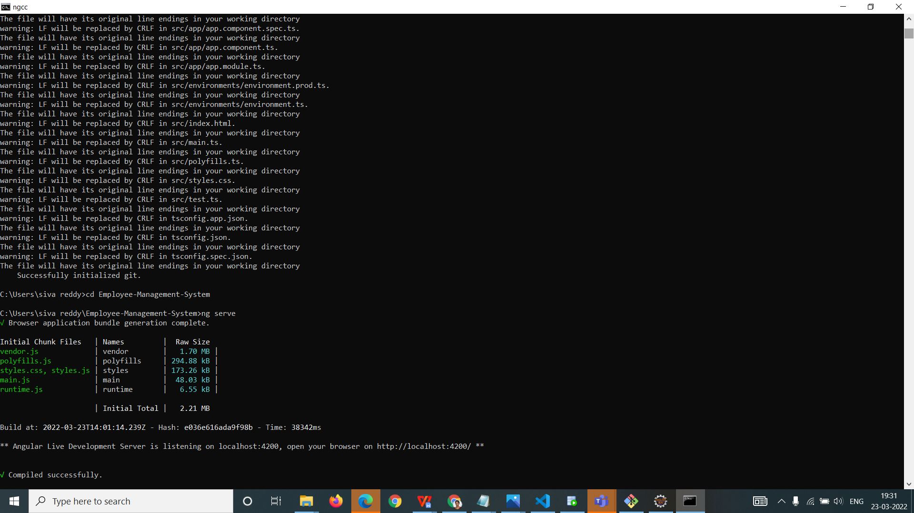

**Project Testing / Access:**

1. **Open URL :** <http://localhost:4200/> **from browser**
2. **To login into the application use Default Login Userid and Default Login Password.**
3. **Once you successfully log into the application, you can use the below application functionalities:**
4. **Search by Bookname**
5. **Search by Authorname**
6. **Search by Category**